**NOTICE**

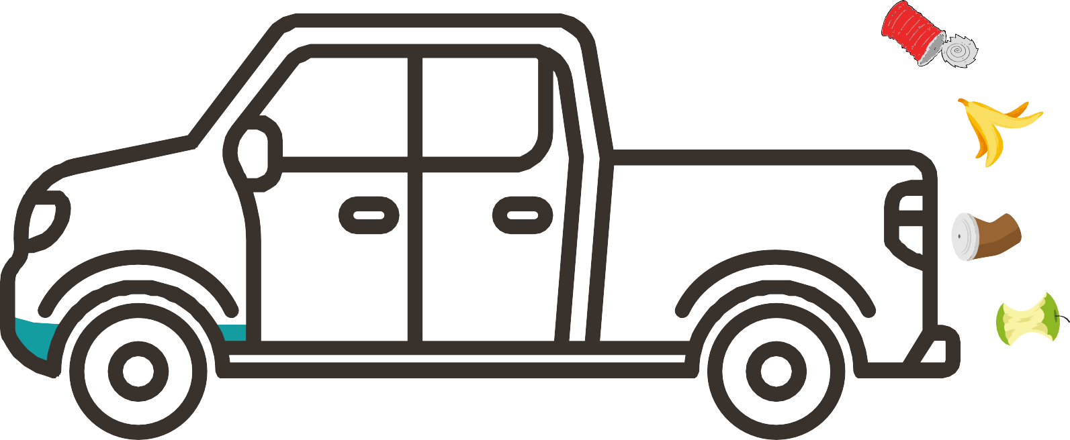

**Landfill FEES TO INCREASE JULY 1, 2023**

THE OTTUWMA/WAPELLO COUNTY LANDFILL FEES

FEES WILL INCRASE ON JULY 1 AS FOLLOWS:

Minimum tipping fee set at $15.50, yard waste fee set at $32.50/ton, with minimum yard waste fee of $8.50, and a load with fire/hot ash double the total fee or a minimum of $175.00 separation charge, $50 for the first load, $100 for the second, and $150 for the third.

The Ottumwa/Wapello County Landfill